Our Church Partnership
We are very proud of our link with our local church, St Andrew and St Patrick, and use it regularly for whole school services and for collective worship as well as making the most of it as a wonderful resource to support our children's learning. Members of the Church community visit us and take an active part in the life of the school as well.
We always publicise events and groups that happen at the church (see here) and have regular displays of our children's work in church.
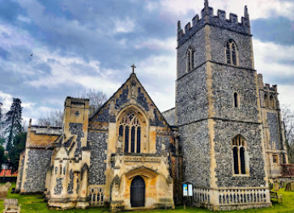

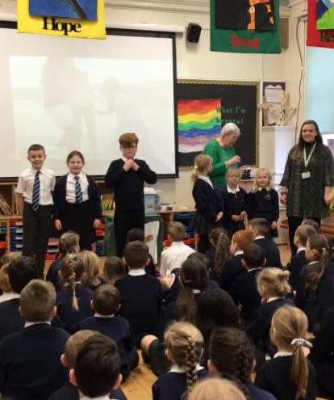
Ash Wednesday, led by Mrs Flack (our Lay preacher). All children were given the opportunity to be ashed if they wished, which many of them did!

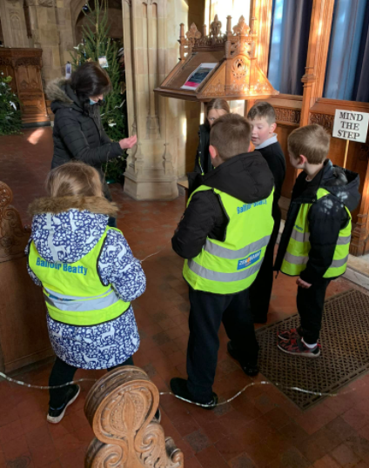
Red Deer participating in the Christmas Tree Festival at the Church as part of the local community.

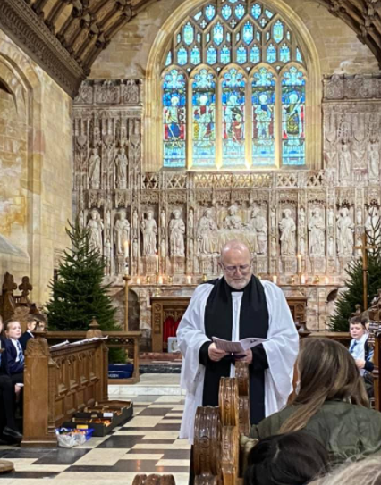
Christingle Service with Reverend Tams (one of our governors), led by Collective Worship team.

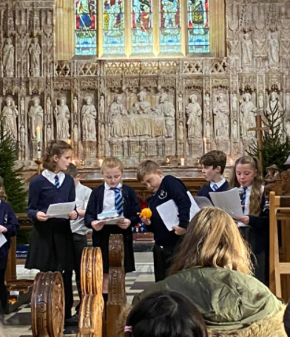
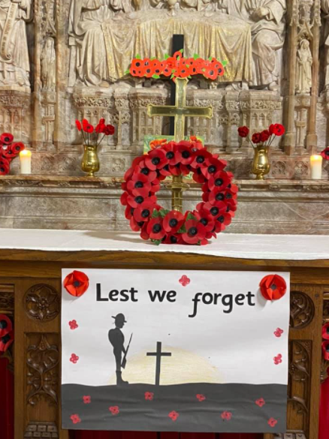
Remembrance day at the church. Each class produced some art work in remembrance with our lay preacher Mrs Flack.
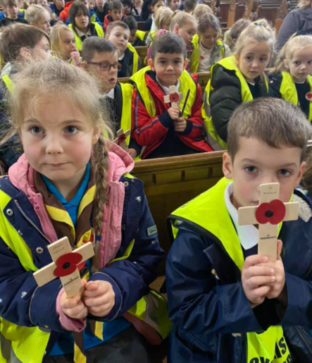
We then planted our crosses in the ground for local men lost in the war.
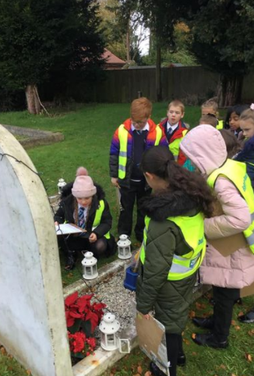
Badgers visiting the grave of Duleep Singh as part of their topic learning about the history of our local community.
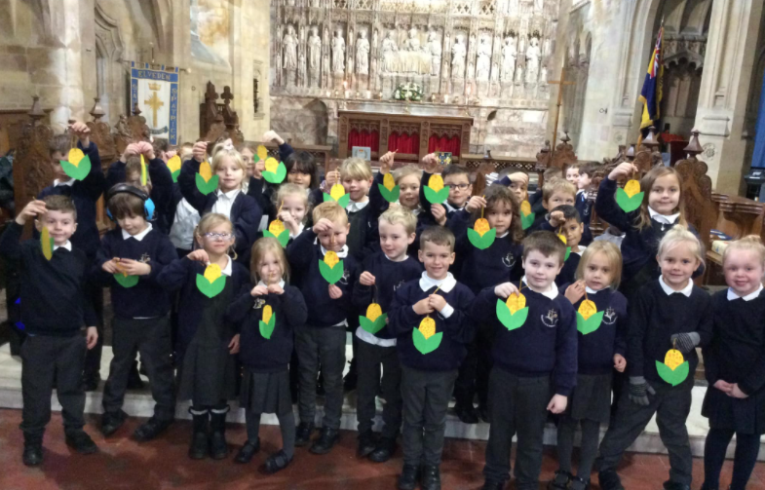
Harvest Festival run by the children and offerings were made to the local Food Bank.
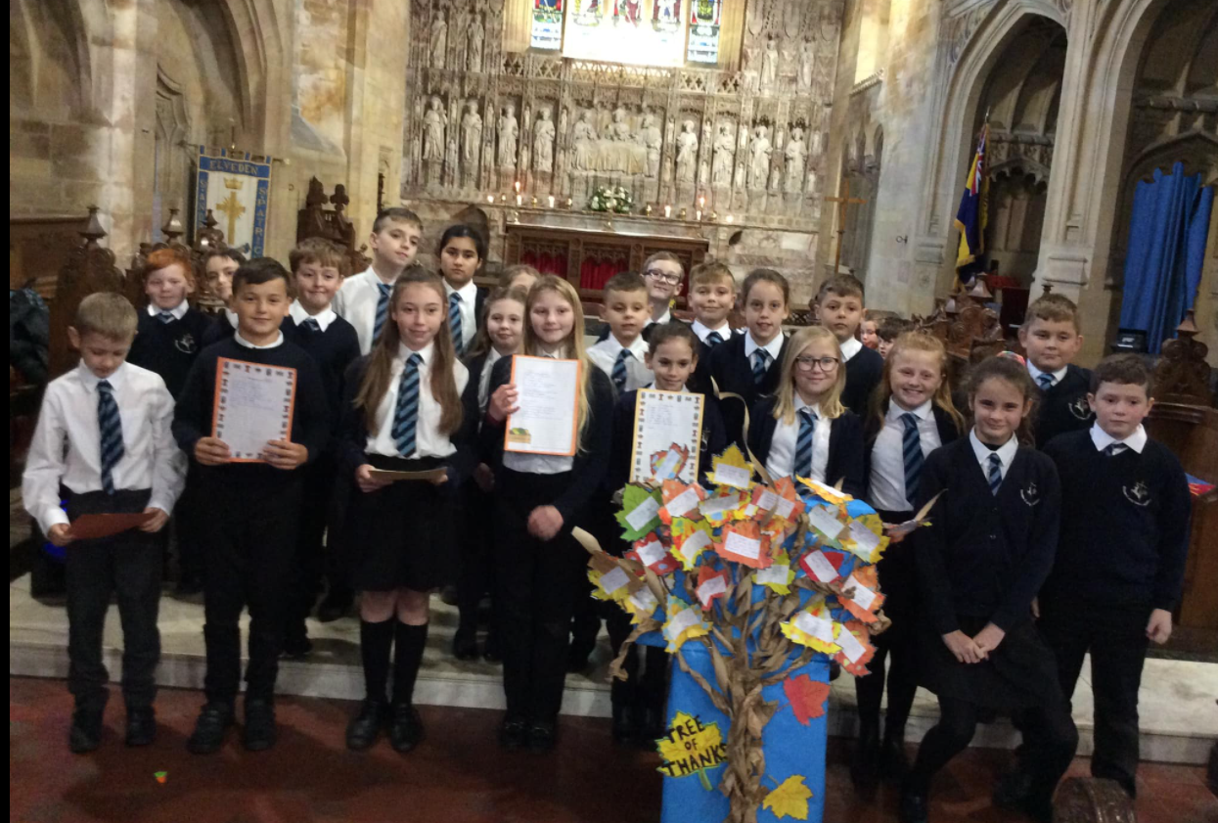
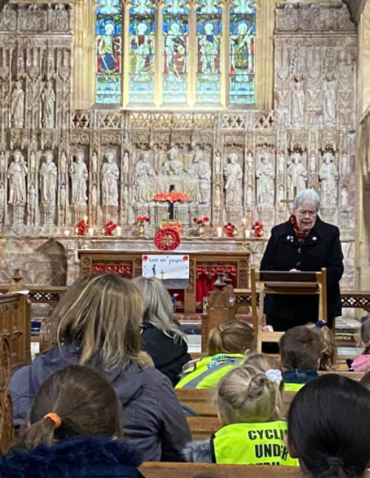
Mrs Flack at our Remembrance, she is our lay preacher and has an active part in school life.
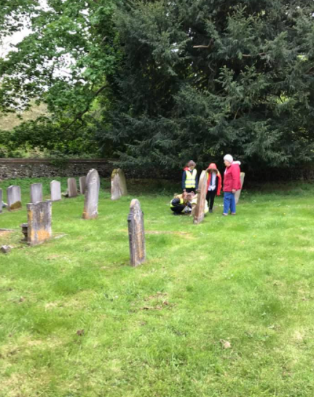
Red Deer visited the church as part of their WW1 topic and visited the graves of local men lost, to show their respect.

