**School**

**Elveden C of E Primary Academy**

**Parent**

**Parent/Carer………………………………………………………………**

**Child**

**Child’s name………………………………………. Class…………**

**I will do my best to:**

* Follow the Class/Bubble rules that keep me safe;
* Wash my hands as soon as I go into school;
* Tell an adult if I feel unwell;
* Bring only essential things into school from home;
* I will bring a water bottle every day as there will be no water fountain, cups or jugs in school;
* Only use the equipment allocated to me;
* Not mix with any other children in the school;
* Only enter and exit the school building from the designated doors/gates;
* Follow the ‘catch it - bin it - kill it’ rules coughing and sneezing into elbow or tissue;
* Regularly wash my hands using soap and water for 20 seconds;
* Follow the rules at all times to maintain the safety of myself and others;
* Avoid using the shared corridors by entering and exiting my classroom using the external doors when possible;
* Only use the toilets in my age-phase group area;
* I will complete all home learning set to ensure I do not fall behind with my learning.

**To help my child at school, I know and understand that:**

* If my child, or anyone in my household, shows symptoms of COVID-19, I will notify the school immediately, I will not send them to school, we will self-isolate for 14 days as a family, I will get them tested immediately and I will let the school know as soon as the results are available;
* If my child shows symptoms of COVID-19 at school, I will collect my child from school immediately. I will get them tested and I will let the school know the results as soon as possible via telephone;
* When dropping my child off and picking them up, I will adhere to the 2 metre social distancing rules;
* I understand that only 1 adult should drop off or collect.
* When dropping off and picking up, I will strictly stick to the school timings for my child;
* My child will only bring essential items into school e.g. reading books, a water bottle, packed lunch, coat, snack
* A pencil case can be brought in as long as it remains in school.
* On PE days, my child will come to school in white T shirt, black jogging bottoms, trainers and school jumper so they do not need to change.
* I will not be allowed into the school without a pre- arranged appointment made via telephone or email;
* I need to support all staff in their efforts to create an ‘as safe as possible’ environment during this time;
* If my child is not able to go to school due to school COVID isolation, I understand it is my responsibility to ensure home learning continues, as set by the school, to prevent my child missing out academically;
* I will read all letters/messages/emails that are sent home;
* I will inform the school of any changes to contacts details.
* I will discuss and reinforce the need to follow the schools Golden Rules and the COVID safety rules with my child.

Signed on behalf of the school Mrs Rourke and Mrs Grimes Date: July2020

Signed by parent/carer…………………………….………………………………. Date……………………………….

**The school will do its best to:**

* Provide an environment which has been risk assessed in response to the COVID-19 infection and Local Authority Risk assessment;
* Adhere to the social distancing rules as set out by the government as much as we reasonably can;
* Provide a curriculum that meets the needs of your child’s well-being, mental health and academic needs;
* Contact parents/carers if your child displays symptoms of COVID-19;
* Inform you if staff or children in your child’s ‘bubble’ test positive for COVID-19 as this will mean you will all need to self-isolate for at least 14 days.
* Continue our clear and consistent approach to rewards and sanctions for children as set out in the Behaviour Policy as well the expectations outlined in this agreement;
* Communicate between home and school through Facebook, notices, newsletters, text, email and the school website.

Signed by child………………………….……………………………………..…… Date……………………………….

**Elveden C of E Primary Academy**

**London Road**

**Elveden**

**Thetford**

**Norfolk**

**IP24 3TN**

**COVID-19**

**Home School Agreement**

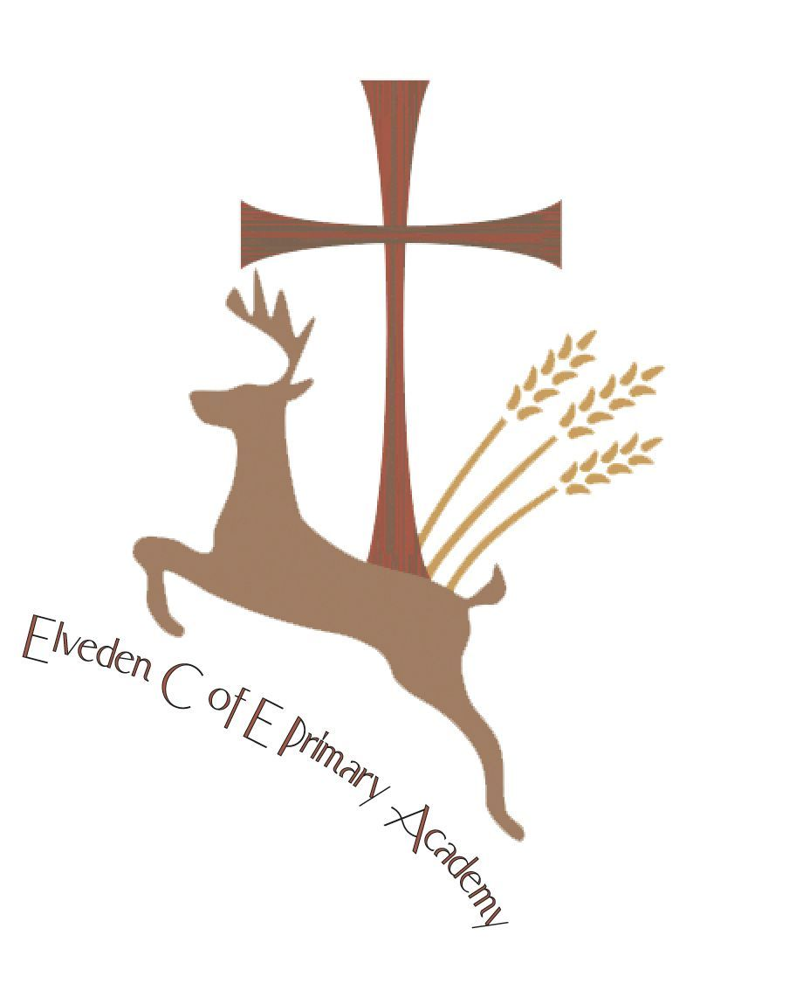

September 2020

**Elveden C of E Primary Academy**

London Road

Elveden

Thetford

Norfolk

IP24 3TN

01842 890258

[enquiries@elvedenacademy.co.uk](mailto:enquiries@elvedenacademy.co.uk)



