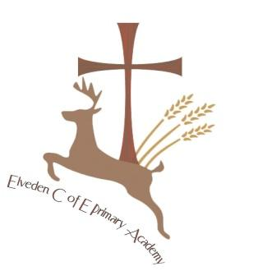
Elveden C of E Primary Academy- School Prayer

Dear God,
We give thanks and praise for our wonderful school families at Elveden Academy.
We pray our school will be a place of great discovery, adventure and creativity.
May it be a place where we love to learn and where we learn to love,
A place where everyone is respected and all are deeply valued,
We ask you to bless us with hope for a bright future and to give us friendship in our hearts.
Please teach us how to forgive and be forgiven so we can be more like you each day.
We ask all this through Jesus Christ our Lord,
Amen

