UKS2 What spiritual pathways to Moksha are written about in Hindu scriptures?
What should we be able to do?
Use the right religious terms to describe that Hindus believe there are different pathways to moksha.
Understand that some Hindus read from the Gita for guidance, comfort and advice.
Express the importance of devotion to Krishna for those who follow the Bhakti pathway.
Give examples of how Hindus express beliefs and feelings about Krishna.
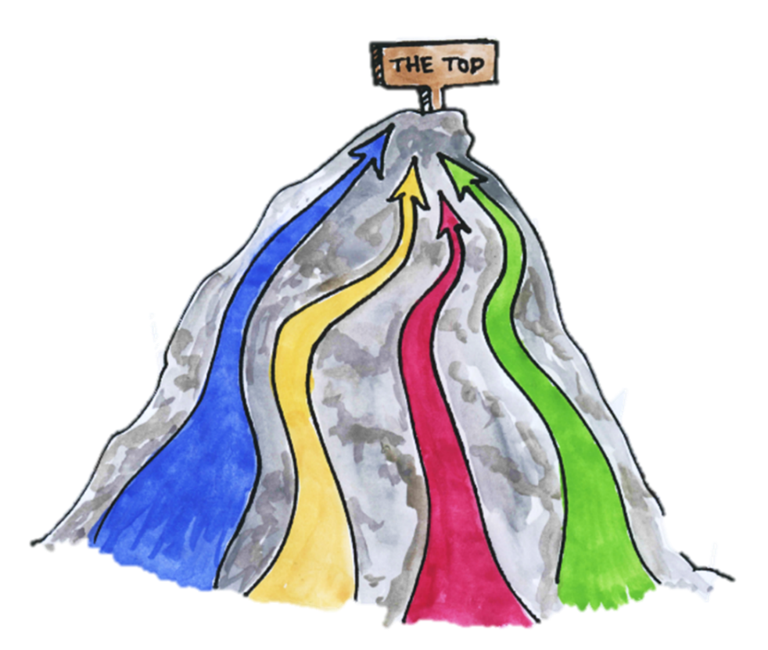
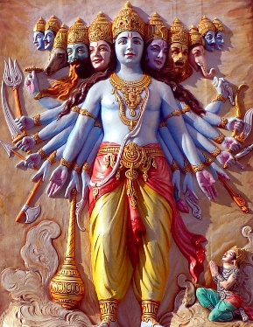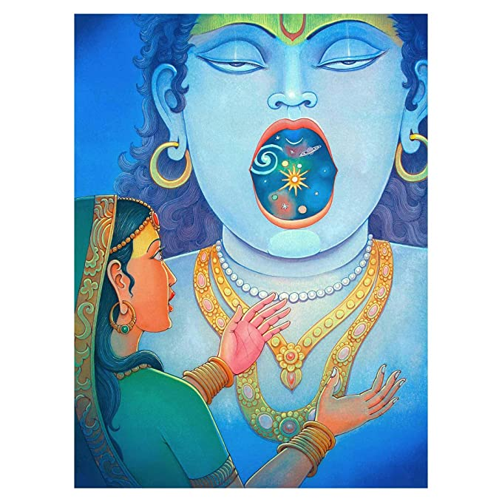
What should we know?
Moksha is freedom from the cycle of birth-death-rebirth (samsara).
That Hindu’s believe:
- Life is a journey towards re-union with God and there are different pathways to achieve this.
- Hindus read from the Gita for guidance, comfort and advice.
- Most Hindus follow Bhakti yoga which teaches people can reach moksha through loving devotion to God.
- Many Hindus direct their devotion to Krishna; they believe that if they focus their love on him he will be their route to moksha.

Prior learning
Hindus believe the soul is reincarnated when we die.
We collect good and bad karma through our actions.
Everyone has their own dharma to fulfil in life. Hindu stories are told about those who follow their duty, no matter what.
Many Hindus show Krishna love and devotion.

Stories help many Hindus feel more devoted to Krishna.

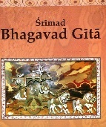
What words should we understand and be able to use?
Moksha | Freedom from samsara. | Gita | Bhagavad Gita – a Hindu scripture.
Samsara | The cycle of birth-death-rebirth. | Bhakti | One pathway to God involving loving devotion.
Yogas | For a Hindu this is a spiritual pathway to link someone with God. | Janmashtami | Krishna’s birthday celebration
Krishna | a major deity in Hinduism. The god of compassion and love.

