Parent’s Purple Mash Uploads
Here is a step by step guide on how to upload your child’s work, so that it can be shared with their teacher. This is really important so all work can be evidenced in one place. Please try to do this each week when children are working in English or Maths books or completing practical tasks for topic etc.
If your child is completing a paper pack and returning each week then this does not need to go on Purple Mash. Don’t forget to keep adding to the ‘Treasured Memories’ page too! This will help us to choose children to be given certificates in our Celebration Assemblies.
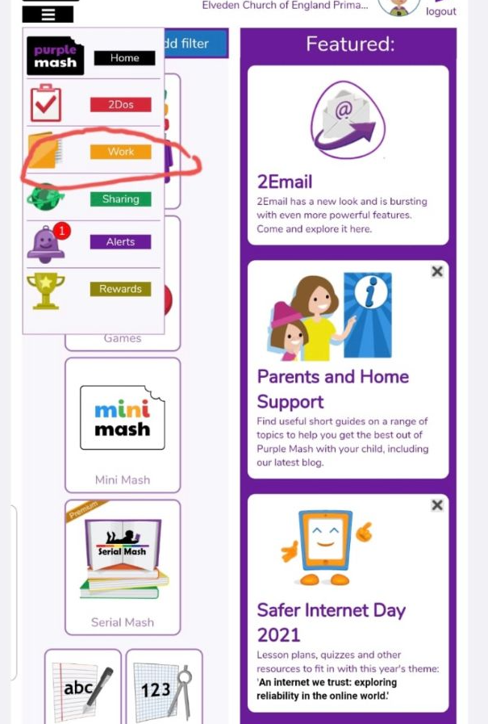
Step 1: From the home screen, click on the WORK folder.

Step 2: On the far right on the screen, click on the 3 dashes. Scroll down and click UPLOAD.
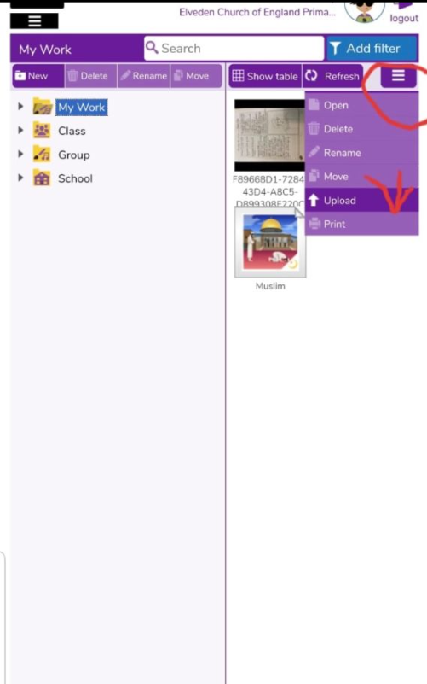

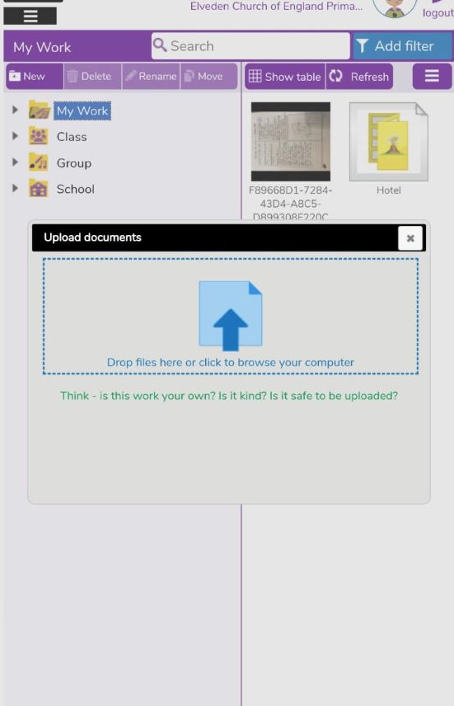
Step 3: You can then upload your child’s work from your device (photo on phone or file on laptop).

Your child’s work will then be shared with their teacher.
Below is also a Parent webinar link that has great tips for activities and tips on how to share their work to their class display board and join their class blog.
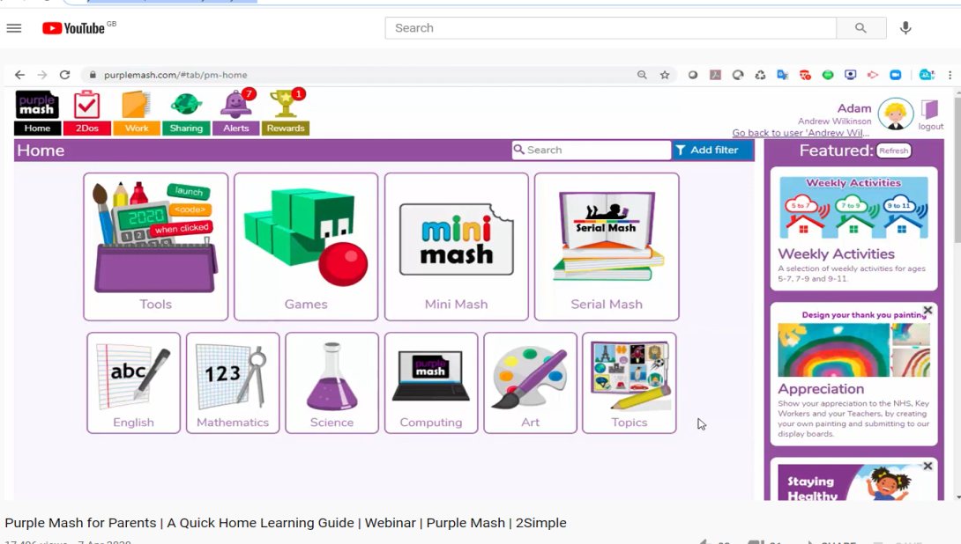
https://www.youtube.com/watch?v=eZyQdS1y3WQ

