Upper Key Stage Two Elveden Academy
Knowledge Organiser: Ancient Egypt
- I am learning to……
- Identify human settlements in Africa.
- Study the geographical features of Africa (Egypt particularly).
- Understand how people lived in the ancient civilisation of Egypt.
- Compare modern and historical life in Egypt.
- Use different sources to build a picture of events.
Ancient Egyptian Time Line
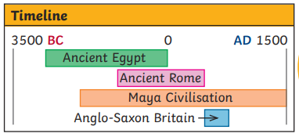
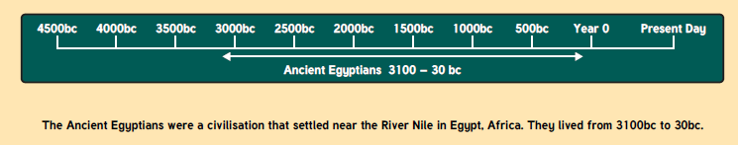

Key Vocabulary:  BC Used to show that a date is before the year 0. This is counted backwards, so 200 BC is before 100 BC.  AD Used to show that a date is after the year 0. This is counted forwards, so AD 100 is before AD 200.  irrigation A system of canals or channels Egyptians dug to supply water to grow crops over a larger area than the water would reach naturally.  silt Fine particles of soil, clay or sand carried and left by water.  hieroglyphics A system of writing that used pictures and symbols (hieroglyphs) instead of letters.’  cartouche An oval shape in which the names of kings and queens were often written in hieroglyphics to show that they were special.  pharaoh A ruler of Ancient Egypt.  pyramid Pyramids were built for Pharaohs (the ruler) to be buried in when they died. Ancient Egyptians were buried with their belongings and the tomb walls were painted with scenes from the dead person’s life.  vizier A high official.  sarcophagus A stone coffin, typically adorned with a sculpture or inscription and associated with the ancient civilizations of Egypt  mummy A body of a human being or animal that has been ceremonially preserved by removal of the internal organs, treatment with natron and resin, and wrapping in bandages.  papyrus A material prepared in ancient Egypt from the pithy stem of a water plant, used in sheets throughout the ancient Mediterranean world for writing or painting on and also for making articles such as rope.  scarab beetle A large dung beetle of the eastern Mediterranean area, regarded as sacred in ancient Egypt.  Tutankhamun Tutankhamun, Egyptological pronunciation Tutankhamen, was an ancient Egyptian pharaoh who was the last of his royal family to rule during the end of the 18th dynasty during the New Kingdom of Egyptian history.  Howard Carter (9 May 1874 – 2 March 1939) Was a British archaeologist and Egyptologist who became world-famous after discovering the intact tomb (designated KV62) of the 18th Dynasty Pharaoh, Tutankhamun (colloquially known as "King Tut" and "the boy king")  discovery The action or process of discovering or being discovered.  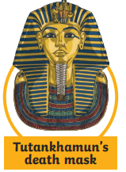  Tutankhamun Fun Facts!  - Born: around 1342 BC  - Died: around 1323 BC  - Pharaoh from approx. 1333 BC to 1323 BC  - Known as the ‘boy king’ as he became pharaoh aged only 9  - Tomb discovered by Howard Carter and his team in the  Valley of the Kings in 1922  - Tomb contained over 3000 treasures  - Historians believe Tutankhamun died suddenly as the tomb was finished hastily. | Geography: Where is Ancient Egypt?  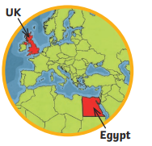  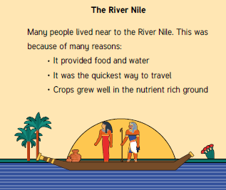  History: Ancient Egyptian Way of Life  