Competition Time
Write a letter to Santa

It’s that time of year again when Santa is waiting to receive all your lovely Christmas letters. He wants to see your very best handwriting and spelling. Let’s impress him!
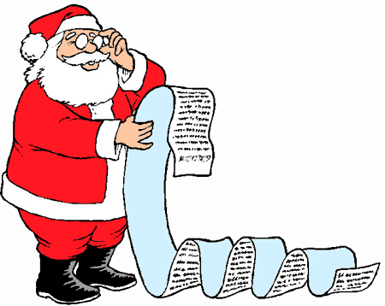

We know that Santa gets thousands of letters every year so you need to make your stand out from the rest. The best way to do that is to make your letter funny or interesting. Make sure you use lots of bright colours and decorations.
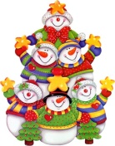

Don’t forget to include your full name and address; we don’t want him getting lost! Bring your letter into school by Thursday 25th November so we can put them all in the special envelope ready to send.
Santa will be choosing some lucky children for a special Christmas treat, but don’t worry if you’re not a winner, at least you will know that your letter has arrived safely at the North Pole.

