Fox Class- Useful Links (08/06/20-12/06/20)
Times tables:
https://www.youtube.com/watch?v=G2iStjfHxrk
Maths support:
https://whiterosemaths.com/
Phonics support:
https://www.phonicsplay.co.uk/
Handwriting
https://www.letterjoin.co.uk/
Maths practise:
www.topmarks.co.uk
Sydney Magazine:
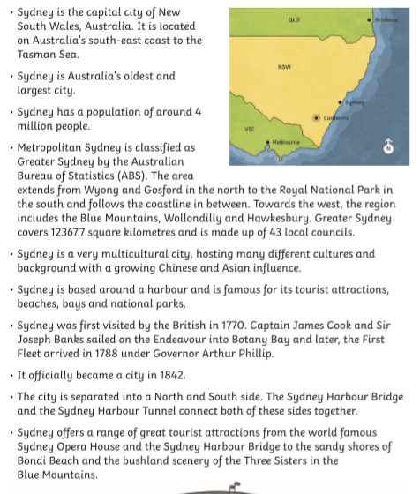

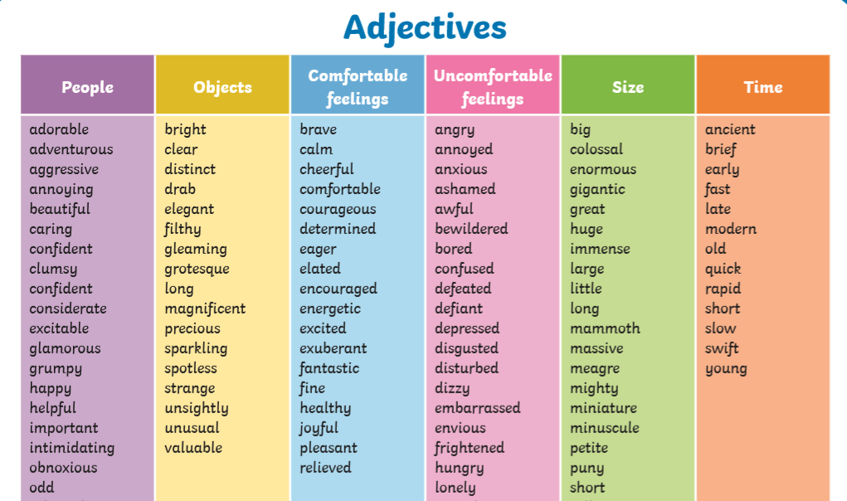
Crashing wave activity:

Writing instructions:
