LKS2 How does the story of Rama and Sita inspire Hindus to follow their dharma?
Prior
learning
Hindus believe we all have a soul.
The soul is reincarnated when we die, it lives on and moves into a new body.
We collect good and bad karma through our actions.

Characters who follow their duty.
What should we be able to do?
Describe what a Hindu might learn from the story of Rama and Sita.
Describe some things Hindus do to celebrate Rama and Sita’s commitment to duty and describe how Hindus celebrate Diwali.
Explain why Hindu children are encouraged to ‘Be as Rama’ or ‘as Sita.’
What should we know?
Dharma is about duty.
Hindu’s believe:
- Everyone has their own DUTY or Dharma to fulfil in life.
- Dharma should be taken seriously -like playing a role in a team.
- Siblings have a duty to look after each other.
- Many Hindu stories are about those who follow their duty, no matter what.
- Hindu marriage joins two people for life, so they can fulfil their dharma together.
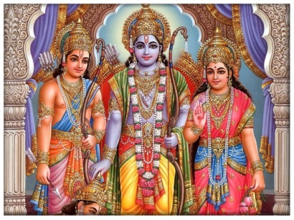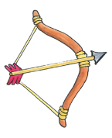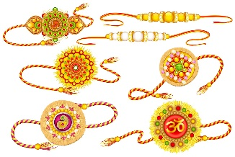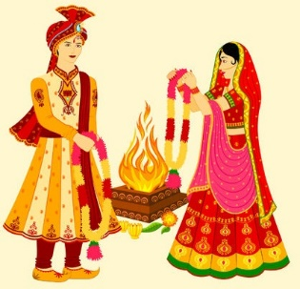

Celebrating sibling duties

Home, family and work all have duties.

What words should we understand and be able to use?
Dharma | This means duty, like playing an important part. Doing your duty. | Diwali | A Hindu festival of new beginnings and the triumph of good over evil, and light over darkness. Known as the 'festival of lights.'
Raksha Bandhan | A Hindu festival celebrating brothers and sisters (siblings) and the love and duty between them. | Divas | 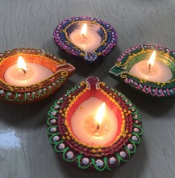  An oil lamp made from clay used during Diwali
Murti | An image, statue or idol of a deity in Hindu culture.  