Elveden Church of England Primary Academy
London Road, Elveden Suffolk, IP24 3TN Tel: 01842 890258
E mail: office@elvedenacademy.co.uk Headteachers : Mrs L Rourke and Mrs A Grimes

To the Parent of: Class:

Dear Parent/Carer,

Your child is one of our children with complex medical needs. In order to offer a safe environment for them we need to ensure that all staff are aware of your child and their potential needs, including what to do in a medical emergency. To make sure that action can be taken quickly when such a response is required we have created a ‘Medical Alert Sheet’ for your child.

The details contained include your child’s name, year and class, a recent colour photograph, along with details of their medical issue or disability, any symptoms and the emergency action that needs to be taken.

We require your consent to display these images in the staff room where all staff can easily access them.

We need to inform you that, if you do not give consent we would need to cover the sheet or find an alternative place to store it, which may lead to a delay in responding to a situation for your child.

These sheets will be updated annually and, if you wish to withdraw consent at any time, please contact the school office

Please can you complete the attached consent slip and return it to the office.

Yours sincerely,

Mrs Grimes and Mrs Rourke

Company Number: 08327233 Working in Partnership with
Forest Academy

Child’s Name Class

- I GIVE consent for a medical alert sheet with my child’s photo and medical information to be displayed in the staff room

- I DO NOT give consent for a medical alert sheet with my child’s photo and medical information to be displayed in the staff room

Parent/Guardian Signature

Date

Yours sincerely,

Mrs Rourke and Mrs Grimes

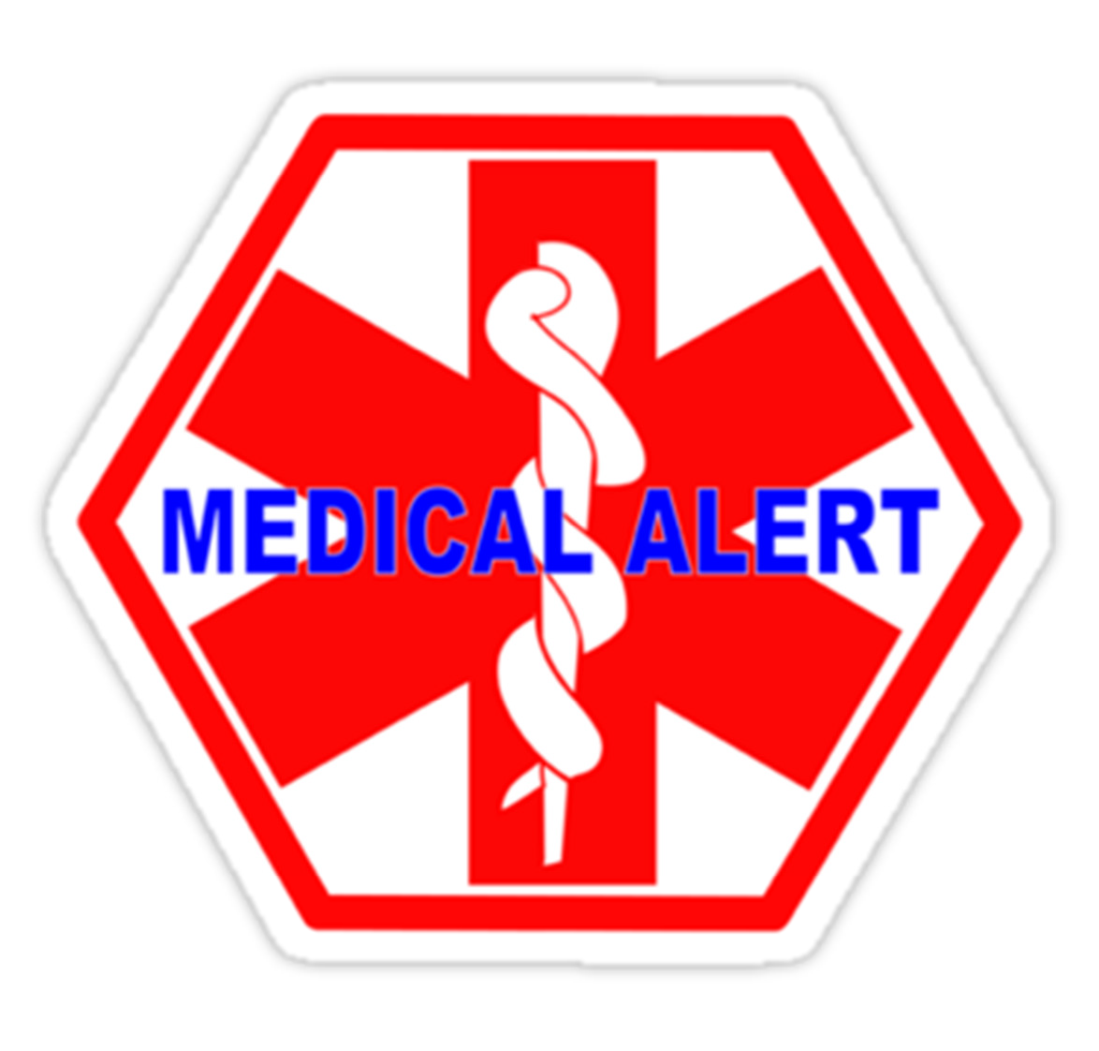

Company Number: 08327233 Working in Partnership with Forest Academy.

