A Guide for Parents and Children using Purplemash at home (Years 1-6) Updated
During school closures, from the 20th April 2020, children will be encouraged to complete their home learning using Purplemash. This is to avoid producing hard copies of the home learning packs, enabling parents and children to remain safely at home rather than coming to school to collect.
This guide explains how to access each week’s learning and to submit their work for teachers to monitor and provide some feedback.
Step 1:
Log in to your account.
https://www.purplemash.com/sch/elveden
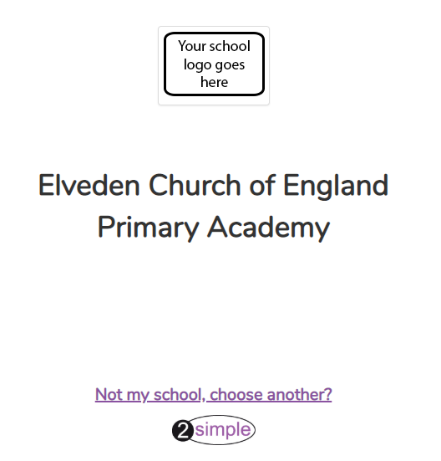
Ensure you are using Elveden Academy’s portal.
Step 2: Be aware that before you do this, some teachers will have set your child personalised tasks in their 2dos, so check these first.
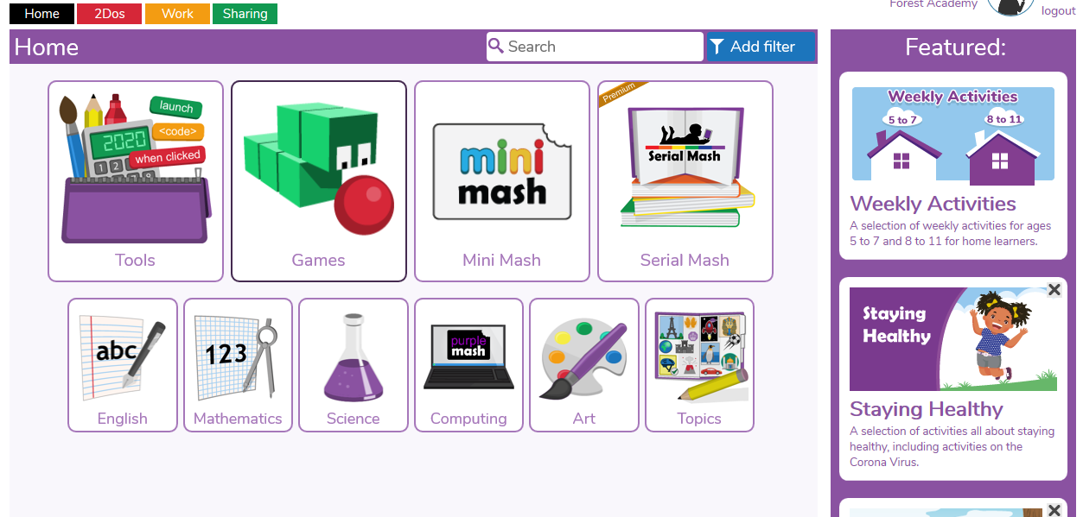
Select ‘Weekly Activities’
Step 3:
Select the age phase that is appropriate to you. There are also some helpful videos on this page to support you with your learning.
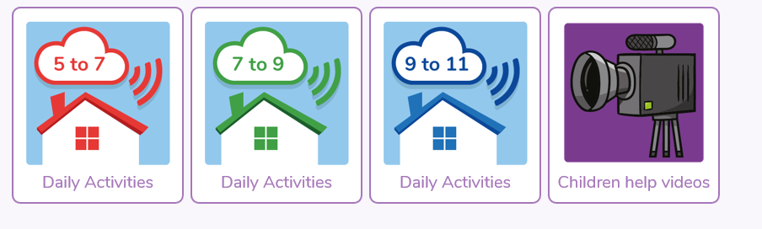
Choose the age group that is right for you.
For example: Foxes choose 5-7yrs, Badgers choose, 7-9 and Red Deer choose 9-11yrs
Step 4:
Once you have clicked on the link for your age phase, start from WEEK 2 (this is updated weekly). There is a folder of activities we would like you to have a go at for each day. Try and have a go at as many of the activities as possible. However, we understand that this may not always be feasible – just try your best! For Year 2-6 we would still like you to use Mymaths for the maths tasks- these will be set by your teacher.
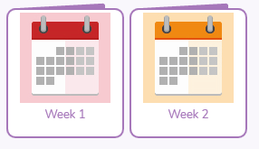
Choose the correct week, starting from Week 2. This is updated weekly with new activities (week 3, week 4 etc).
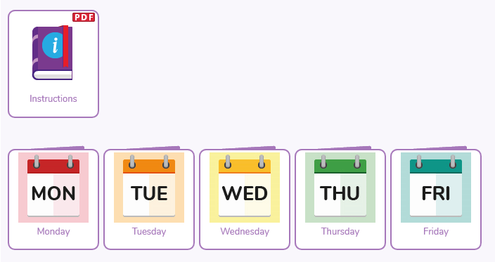
Choose the day of the week.
Step 5:
Have ago at completing your chosen task – most are online but there are some that you can print at home if you are able to. Some are just for fun and to keep your brain active, others can be submitted for your teacher to look at. Look for the purple box with three white lines at the top left corner of the page. Click on this and select ‘Save’.
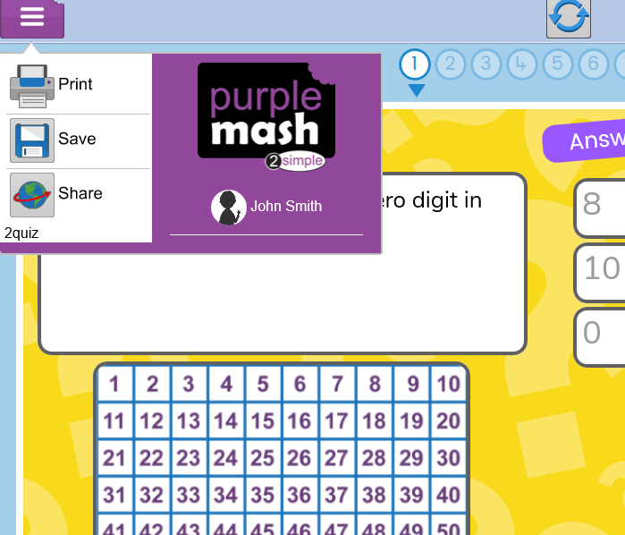
Click here to save
Step 6:
Once you press save, make sure you select your class name NOT ‘To my PC’ or ‘My Work’. This means your teacher will be able to see the work you have submitted.
Make sure when you save your work, you save it in your class folder (e.g. Primrose) so that your teacher can see it! You will receive a message.
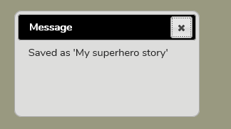
Step 7:
Look out for alerts! If your teacher is able to, they will respond to the learning you have submitted.
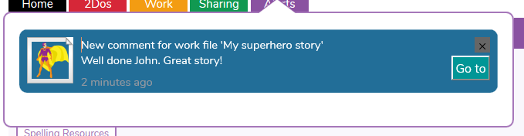
Look out for an alert from your teacher!

Other websites that we recommend and you can use alongside Purplemash:
For English:
https://www.bbc.co.uk/iplayer/episodes/b01cz0p1/alphablocks
https://www.phonicsplay.co.uk/
https://readingeggs.co.uk/
https://www.teachyourmonstertoread.com/
https://www.worldofdavidwalliams.com/elevenses/
Children who have access to Lexia, should also continue to use this regularly.

For Maths:
https://www.bbc.co.uk/iplayer/group/b08bzfnh (Numberblocks)
https://whiterosemaths.com/homelearning/
https://mathsframe.co.uk/
https://www.topmarks.co.uk/
https://www.ictgames.com/
In addition to this, you can continue to use MyMaths.
Keeping safe online
It is important that with the increased amount of time children are spending online, parents are extra vigilant. The government have provided guidance; full details can be found in section 6.3 of the guidance for parents and carers on the closure of educational settings:
https://www.gov.uk/government/publications/closure-of-educational-settings-information-for-parents-and-carers?fbclid=IwAR0ev17vnNTFBgVjpkU--i-nKJPECTwoVqqdl3E9-dXrt_7lPI4ur7StGbc
Please talk to your children about this and report any concerns you may have. This can be done via the CPOC button on our website or contact us at enquiries@forestacademy.co.uk
