**LKS2 Why do Muslims call Muhammad the ‘Seal of the Prophets’?**

**What should we know?**

A **prophet** is chosen by God and provides guidance in the form of a good example to follow. Muslim’s believe:

* Allah has sent many messengers into the world to call people back to him when they have behaved badly.
* Muhammad was chosen by Allah to be his final prophet.
* Muhammad is greatly respected by Muslims but he is not to be worshipped.
* Muhammad told people to submit to Allah and to worship no-one else.

**What should we be able to do?**

*Explain that Muslims believe Muhammad was a messenger of God and the last prophet and recall something about his life.*

*Describe the Shahadah and know all Muslims everywhere recite the same words.*

*Describe what Muslims might learn from a story about Muhammad’s life.*

*Describe some different ways Muslims show their beliefs about Muhammad such as in art, calligraphy or design.*

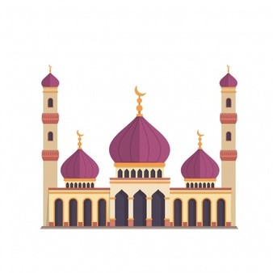

[](http://previews.123rf.com/images/meenna/meenna1508/meenna150800071/43578719-vecteur-arabische-shahada-Banque-d'images.jpg) 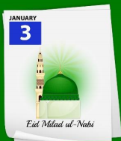

**Prior**

**learning**

Muslims believe Allah is the one true God and should be obeyed in every way.

Muslims trust him to tell them the right thing to do.

Praying five times a day helps them to remember to submit to Allah in all they do.

Finding evidence of Muhammad in a mosque.

Celebrating Muhammad’s birthday.

There is no God but Allah and Muhammad is the messenger of God.

**What words should we understand and be able to use?**

|  |  |  |  |
| --- | --- | --- | --- |
| **Prophet** | Someone chosen by God to deliver a message. Muslims believe Allah sent thousands of prophets, but Muhammad was the last one. | **Muhammad** | Allah’s final prophet. |
| **Mosque** | A Muslim place of prayer where Muslims submit themselves to Allah. It is also a community centre and place of study. | **Shahadah** | The Muslim profession of faith (‘there is no god but Allah, and Muhammad is the messenger of Allah’) |