**UKS2 What does the Qur’an reveal about Allah and his guidance?**

**What should we know?**

**Revelation** is how Allah imparts whatever he wishes to those he chooses.

Muslim’s believe:

* The greatest revelation has come from Allah to the Prophet Muhammad and is recorded in the Qur’an.
* The Qur’an reveals what God is like, provides guidance for living and the key to preparation for the life to come.
* The words of the Qur’an are the actual words of Allah received over a period of time by the Prophet Muhammad through the Angel Jibreel (Gabriel).

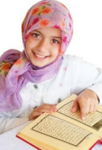

**Prior**

**learning**

That Allah is the one true God – compassionate and merciful. He should be obeyed in every way.

Muhammad – revered but not to be worshipped - was chosen by Allah to be his final prophet.

Muhammad told people to submit to Allah and to worship no-one else.

**What should we be able to do?**

*Explain how Muslims show respect for the Qur’an.*

*Retell the story of how the Qur’an was revealed to Muhammad.*

*Describe some practices and experiences of Muslim children at a madrassah.*

*Describe why only some Muslims seek to become Hafiz and how the study affects both their lives and the lives of others.*

*Show how Muslims express the idea of revelation as a rope reaching down to earth, suggesting what the image means.*

*Make links that show how Muslim belief and practices come from the teachings of the Qur’an or from the Sunnah of the Prophet.*

Prayer beads – reminder of Allah’s 99 names.

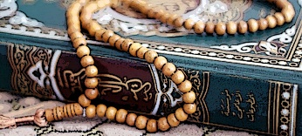

Muslim children learn to recite the Qur’an in Arabic.

The Qur’an – the final revelation from Allah.

**What words should we understand and be able to use?**

|  |  |  |  |
| --- | --- | --- | --- |
| **Revelation** | How Allah makes himself known to Earth. | **Cave Hira** | Where Muhammad received the Qur’an. |
| **Madrassah** | A Muslim school (often part of the Mosque). Children learn to recite the Qur’an here often two hours after school and on a Saturday. | **Hafiz** | Someone who has memorised the Qur’an off by heart. |