LKS2 How do Sikhs put their beliefs about equality into practice?
What should we be able to do?
Describe some similar things Sikhs do when they come to the gurdwara for worship and those which demonstrate equality.
Describe how the names ’kaur’ and ‘singh’ show the belief that all Sikhs are equal, valued and united.
Explain and describe the practice of the langar.

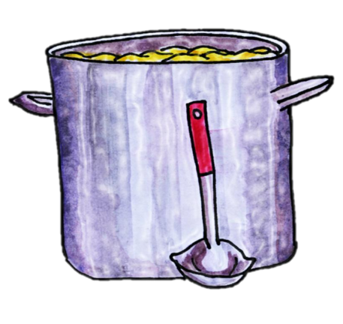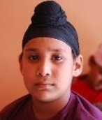
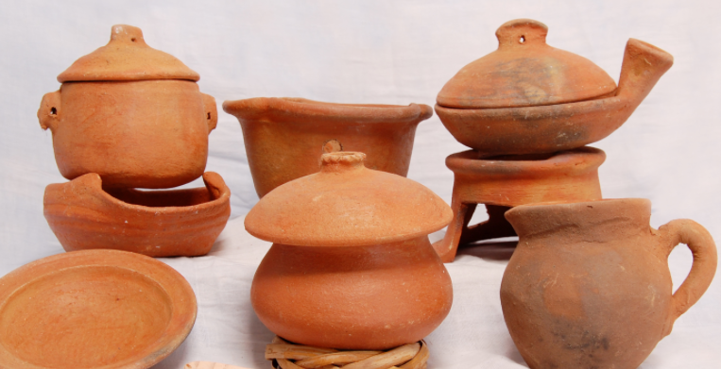
What should we know?
Sikhs believe everyone is equal.
That Sikh’s believe:
- Guru Nanak taught that God was present in everyone.
- Everybody is equal because God is in each heart.
- All Sikh boys are called Singh, and girls Kaur. These extra names show all are equal and important to God.
- Eating together in the langar helps put equality in practice. No one is more important than anyone else.
- In the Gurdwara, worshipping together reminds Sikhs they are all equal.
Prior learning
Sikhs believe in one God ‘Waheguru.’
We are all children of God.
Guru Nanak was the first Guru. The Guru Granth Sahib the last.
Sikhs are encouraged to listen and meditate on its words to know God better.

The clay is the same but the Cosmic Potter has fashioned vessels of many kinds…

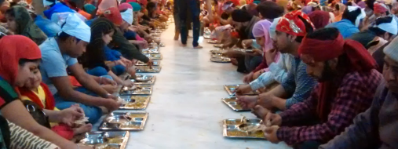
What words should we understand and be able to use?
Singh | Means ‘lion’ a name for all Sikh boys. | Patka | A Sikh head covering which is worn by many Sikh children in preference to its 'bigger brother' the turban.
Kaur | Means ‘princess’ a name for all Sikh girls. | Gurdwara | Where Sikhs meet as a community.
Langar | The free kitchen at the Gurdwara where all can eat. All are expected to help serve here.

