UKS2 How did Buddha teach his followers to find enlightenment?
What should we be able to do?
Retell the story of Buddha’s enlightenment.
Explain how and why a Buddhist uses the image of a lotus to explain beliefs about growing towards enlightenment.
Describe different practices of Buddhists in search of enlightenment on the Eightfold Path.
Explain Buddhist teachings including reference to the four noble truths.
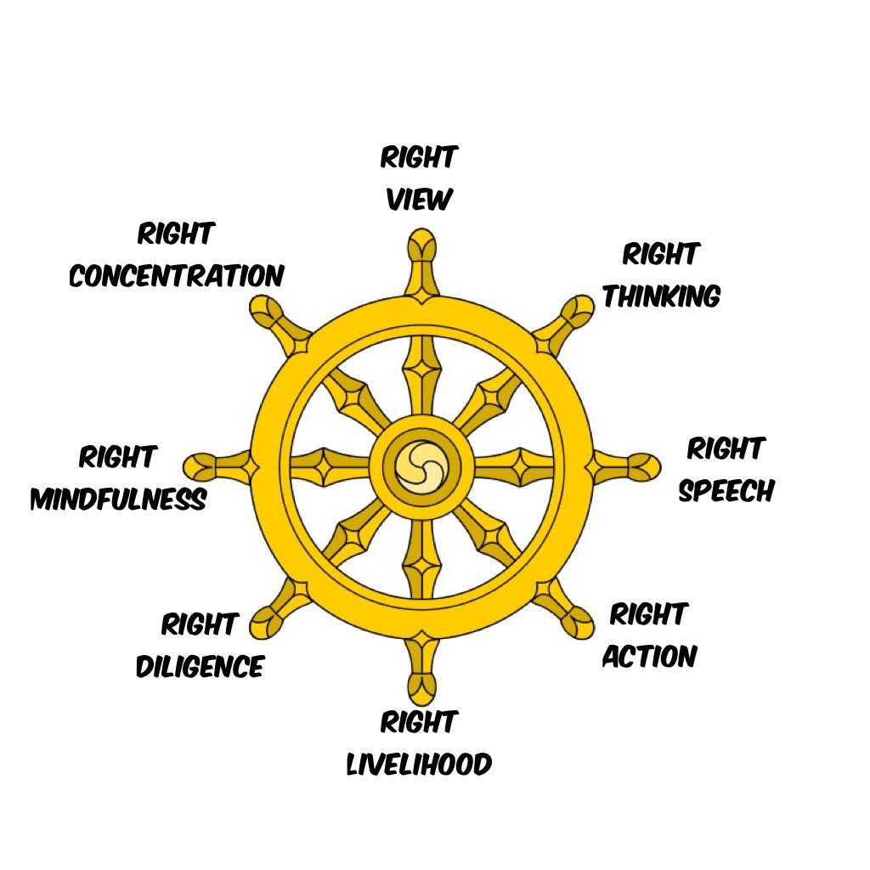
What should we know?
Enlightenment means having a fully awake understanding.
Buddhist’s believe:
- All humans have the potential to be enlightened or awakened spiritually.
- The Buddha achieved enlightenment sitting under a Bodhi tree. He worked out what was wrong with humans – that we all experience suffering.
- The Buddha explained his ideas as Four Noble Truths.
- Following the teachings of the Buddha found in the Eightfold Path is a way to end suffering.
- They can become enlightened through meditation.
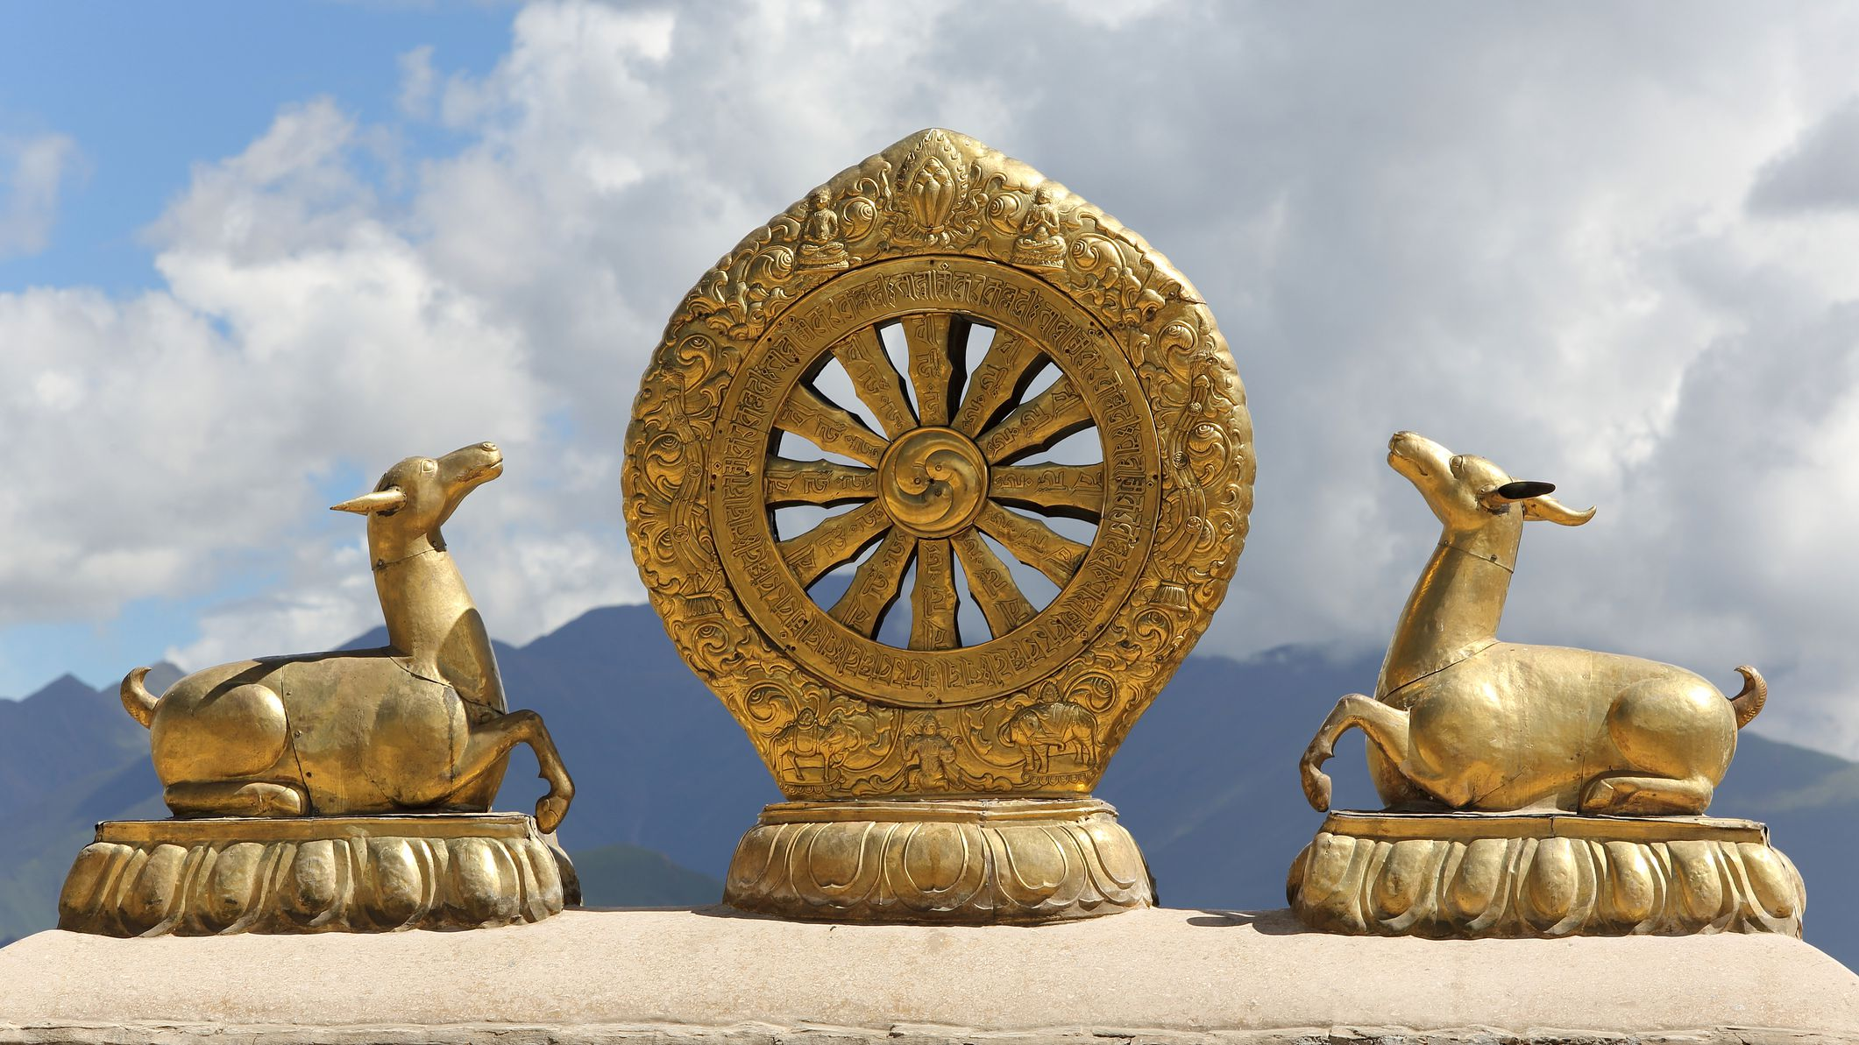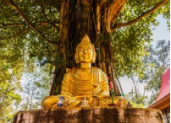
The Dharma wheel

The lotus flower - Even from a murky start, humans can achieve enlightenment.

What words should we understand and be able to use?
Buddha | The Buddha (also known as Siddhartha Gotama) was a spiritual teacher who lived in Ancient India. He is revered as the founder of the world religion of Buddhism. | Dharma wheel | The Noble Eightfold Path is often represented by means of the dharma wheel.
Enlightenment | Being fully awakened spiritually. | Four noble truths | The Buddha’s teaching: the truth of suffering, the truth of the cause of suffering, the truth of the end of suffering, and the truth of the path that leads to the end of suffering.
Eightfold path | The path Buddhists follow to end suffering. The last of the four noble truths. | Meditation | For Buddhists, meditation is a way of taking control of the mind.

