


Safeguarding Overview for Prospective Employees
(updated November 2017)

Introduction
The purpose of this safeguarding induction booklet is to give you a brief overview of the school and your Safeguarding duties and requirement. It will help you to know what your role and responsibilities would be and what to do if you have concerns about a child or young adult.
If you are not sure what to do or feel anxious when dealing with any safeguarding issues, remember you can speak to our Designated Safeguarding Leads (DSL) who are:
April Grimes, Lorna Rourke, Kathy Harris, Zoe Huff or Sam Gough

What is Safeguarding and Child Protection?
Definitions:
Safeguarding and promoting the welfare of children is defined as:
- Protecting children from maltreatment
- Preventing impairment of children’s health or development
- Ensuring that children are growing up in circumstances consistent with the provision of safe and effective care
- Taking action to enable all children to have the best outcomes.
Children includes everyone under the age of 18
Keeping Children Safe in Education, 2016
Abuse: a form of maltreatment of a child. Somebody may abuse or neglect a child by inflicting harm, or by failing to act to prevent harm. They may be abused by an adult or adults or another child or children. Abuse can take place in any family, institution or community setting, by telephone, enabled through internet, mobile devices or dependent on the use of the internet.
Abuse can often be difficult to recognise as children may behave differently or seem unhappy for many reasons, as they move through the stages of childhood or their family circumstances change.

Safeguarding key principles
Effective safeguarding arrangements in every local area should be underpinned by two key principles:
• Safeguarding is everyone’s responsibility. Everyone who comes into contact with children and their families and carers has a role to play in safeguarding children:
• All professionals should make sure their approach is child-centred. This means that they should consider, at all times, what is in the best interest of the child.

What is my role and responsibilities?
You are in a unique position to be able to observe signs of abuse or neglect, or changes in behaviour which may indicate a child, young person or young adult may be being abused or neglected.
You should make sure that you are alert to the signs of abuse and neglect, that you question the behaviour of children, parents, carers or colleagues and don’t necessarily take what you are told at face value. You should make sure you know where to turn to if you need to ask for help, and that you refer to children’s social care or to the police, if you suspect that a child is at risk of harm or is in immediate danger.
Sections17, 27 and 47 Children Act 1989 respectively, requires:
• Local Authorities (LA) to safeguard and promote the welfare of children in need and provide appropriate services.
• Local Authorities and other organisations to assist in the exercise of functions, including those under section 17.
• Local Authorities to make child protection enquiries if they have reasonable cause to suspect a child in their area is suffering or is likely to suffer significant harm, and for schools and other organisations to assist them with those enquiries.
Section 175 and section157 Education Act 2002 require local authorities and Governing Bodies of maintained schools and FE colleges, Academies, Free Schools and Independent schools to:
• make arrangements to ensure that their functions are carried out with a view to safeguarding and promoting the welfare of children, and
• have regard to any guidance issued by the Secretary of State in considering what arrangements they need to make for that purpose.
All school and college staff have a responsibility to provide a safe environment in which children can learn.
All school and college staff should be prepared to identify children who may benefit from early help. Early help means providing support as soon as a problem emerges at any point in a child’s life, from the foundation through to the teenage years.
In the first instance, staff should discuss early help requirements with the DSL. Staff may be required to support other agencies and professionals in an early help assessment.
Any staff member who has a concern about a child’s welfare should follow the referral processes set out in paragraphs 21-27 of the Keeping Children Safe in Education guidance which should be reflected in the schools safeguarding policy. Staff may be required to support social workers and other agencies following any referral.
The Teachers’ Standards 2012 state that teachers, including headteachers, should safeguard children’s wellbeing and maintain public trust in the teaching profession as part of their professional duties.

All staff who will work with children, whether permanent, temporary or voluntary, including governors, should, when starting work, be:
- made aware of and given a written statement about the school or institution’s safeguarding arrangements and Part 1 of the Keeping Children Safe in Education 2016 guidance
- made aware of their responsibilities and be given the name and contact details of the DSL
- All staff who work with children, including teachers and governors, but do not have designated safeguarding role with responsibilities should undertake
- basic introduction to safeguarding training that equips them to recognise and respond to child welfare concerns
- additional safeguarding training appropriate to their role, including training provided by the DSL, the Local Authority (LA) or the Local Safeguarding Children Board (LSCB)
- undertake refresher training at least every three years and regular safeguarding updates at least annually.

What would I look for and how would I know a child, young person or young adult is at risk?

Recognising concerns and signs of child abuse.
Safeguarding is not just about protecting children from deliberate harm. It also includes such things as:
- Pupil safety
- being aware of bullying, racism, harassment and homophobic bullying including where this takes place online
- arrangements around health and safety on educational visits, activities intimate care
- children missing education and child sexual exploitation and vulnerability to radicalisation, extremism and other safeguarding issues such as Female Genital Mutilation and peer abuse.
The witnessing of abuse can have a damaging effect on those who are party to it, as well as the child subjected to the actual abuse, and in itself will have a significant impact on the health and emotional well-being of the child.
However, it is important to know the signs of abuse and to be alert to the need to consult further and to act if abuse is suspected or taking place.

Four recognised categories of abuse
The following signs listed under the four recognised categories of abuse are not an exhaustive list.
Physical abuse: a form of abuse which may involve hitting, shaking, throwing, poisoning, burning or scalding, drowning, suffocating or otherwise causing physical harm to a child. Physical harm may also be caused when a parent or carer fabricates the symptoms of, or deliberately induces, illness in a child.
Emotional abuse: the persistent emotional maltreatment of a child such as to cause severe and adverse effects on the child’s emotional development. It may involve conveying to a child that they are worthless or unloved, inadequate, or valued only insofar as they meet the needs of another person. It may include not giving the child opportunities to express their views, deliberately silencing them or ‘making fun’ of what they say or how they communicate. It may feature age or developmentally inappropriate expectations being imposed on children. These may include interactions that are beyond a child’s developmental capability as well as overprotection and limitation of exploration and learning, or preventing the child participating in normal social interaction. It may involve seeing or hearing the ill-treatment of another. It may involve serious bullying (including cyberbullying), causing children frequently to feel frightened or in danger, or the exploitation or corruption of children. Some level of emotional abuse is involved in all types of maltreatment of a child, although it may occur alone.
Sexual abuse: involves forcing or enticing a child or young person to take part in sexual activities, not necessarily involving a high level of violence, whether or not the child is aware of what is happening. The activities may involve physical contact, including assault by penetration (for example rape or oral sex) or non-penetrative acts such as masturbation, kissing, rubbing and touching outside of clothing. They may also include non-contact activities, such as involving children in looking at, or in the production of, sexual images, watching sexual activities, encouraging children to behave in sexually inappropriate ways, or grooming a child in preparation for abuse (including via the internet). Sexual abuse is not solely perpetrated by adult males. Women can also commit acts of sexual abuse, as can other children.
Neglect: the persistent failure to meet a child’s basic physical and/or psychological needs, likely to result in the serious impairment of the child’s health or development. Neglect may occur during pregnancy as a result of maternal substance abuse. Once a child is born, neglect may involve a parent or carer failing to: provide adequate food, clothing and shelter (including exclusion from home or abandonment); protect a child from physical and emotional harm or danger; ensure adequate supervision (including the use of inadequate care-givers); or ensure access to appropriate medical care or treatment. It may also include neglect of, or unresponsiveness to, a child’s basic emotional needs.
(Source: Working Together to Safeguard Children 2015 Appendix A pp 92-93, Keeping Children Safe in Education 2016 pp 11 para 35-40).
In relation to adults, there is a different legislative and policy base for responding to their safeguarding needs including financial/material abuse or discrimination. However, most of the principles and procedures that apply are the same as those for safeguarding children and young people. In addition to the above categories and signs of abuse safeguarding action may be needed to protect children and learners from:
- child sexual exploitation (CSE) – see also below
- bullying including cyberbullying
- domestic violence
- drugs
- fabricated or induced illness
- faith abuse
- female genital mutilation (FGM)
- forced marriage
- gangs and youth violence
- gender-based violence/violence against women and girls (VAWG)
- mental health
- private fostering
- preventing radicalisation
- hate
- sexting
- teenage relationship abuse
- trafficking
- children missing from home or care
- children missing education
- children and adult missing strategy
- poor parenting, particularly in relation to babies and young children
- other issues not listed here but that pose a risk to children, young people and vulnerable adults.
(Source: Keeping Children Safe in Education 2016, pp 12)

What if I have concerns about another colleague or trusted adult?
When staff have concerns about another adult’s behaviour or allegations arise, it is inevitably a distressing and difficult time for all concerned. It is important that you raise any concerns at the earliest opportunity so that incidences can be dealt with quickly and fairly.
- Pinpoint what practice is concerning you and why
- voice your concerns, suspicions or uneasiness as soon as possible
- don’t think “What if I’m wrong?” think “What if I’m right?”
- seek support, guidance and advice without delay from your DSL
- if you have concerns about the headteacher report this to your Chair of Governors
- self-report if you think you got it wrong, or if your behaviour may have been misinterpreted.
Whistleblowing is the mechanism by which adults can voice their concerns, made in good faith, without fear of repercussion. It is important that you understand the whistle-blowing procedures of your school/education setting and who to talk to if you have a concern about another adult. For example, if you are concerned that an adult in a position of trust may be bullying or sexually abusing a child or young person.
Managing allegations against adults.
Suffolk Local Safeguarding Children Board: Allegations against staff, carers and volunteers
This protocol sets out the locally agreed arrangements for responding to allegations against staff, carers and volunteers who work with children. It is informed by the statutory requirements of Working Together to safeguard children, 2016 pp 54-55 and the Keeping Children Safe in Education 2015, Part four pp 36-46
All organisations and places of employment should have procedures for
dealing with allegations, and all staff and volunteers should understand what
to do if they receive an allegation against them or have concerns regarding the
behaviour of another member of staff, volunteer or visitor. This information
must be explicit in service procedures and made available to all members of
staff, regular visitors, volunteers and service users.

All procedures should make clear that all allegations should be reported within
one working day to the senior manager or employer for the organisation with
operational responsibility for dealing with allegations.

All procedures should also include the contact details for the LA Designated
Officer(s) (LADO) responsible for providing advice and monitoring cases.
The allegation should then be discussed with the LADO on the same day.
Remember:

- All allegations must be taken seriously and properly investigated in accordance with local procedures and statutory guidance.

- In the event of any allegation being made to you by a child or another adult you must pass the information on.

- DO NOT INVESTIGATE. Discuss with the LADO in the first instance.

- You must make a clear record of the allegations and report this to the head teacher without delay. (Don’t forget to date and sign it)

- If the allegation is about the headteacher, you should report the information to the Chair of Governors.

- Adults who are the subject of allegations are advised to contact their professional association.

Local Authority Designated Officer (LADO) contact details
The Director for Children and Young People Service has identified dedicated staff to undertake the role of Local Authority Designated Officers. LADOs can be contacted via email on LADOCentral@suffolk.gcsx.gov.uk or by using the LADO central telephone number 0300 123 2044 for allegations against all staff and volunteers.
LADOs can be contacted via email on LADOCentral@suffolk.gcsx.gov.uk or using the LADO central telephone number 0300 123 2044 for allegations against all staff and volunteers

Talking to children & young people
It is important that you know how to respond appropriately to children and adults if they disclose abuse or if you have concerns.
If a child has chosen to speak to you it is because they feel that you will listen and that they can trust you. You need to listen to what the child has to say, and be very careful not to ‘lead’ the child or influence in any way what they say.
DO | DON’T
Stay calm  Listen and be supportive  Tell the child what you will do next  Record in writing what was said.  Inform the DSL of your concerns immediately  Seek support for yourself  Remember… | Dismiss what the child is telling you  Ask any leading questions, interrogate the child, or put ideas into the child’s head, or jump to conclusions  Stop or interrupt a child who is recalling significant events  Promise the child confidentiality You must explain that you will need to pass on information to keep them safe  Express an opinion about the alleged perpetrator of the abuse  Tell the child everything will be ‘OK’
Remember…
- BE ALERT to it
- RECOGNISE the SIGNS of abuse
- Act in the ‘BEST INTEREST’ of the child
- DO NOT INVESTIGTE but be ready to CONTRIBUTE to a social work assessment
- SEEK ADVICE and support from the Designated Safeguarding Lead
- RECORD your concerns
- TAKE appropriate ACTION by passing the information on
- REFER WITHOUT DELAY

If in doubt about whether to refer, please call the MASH professional helpline below


Four key steps to follow, in helping you, to identify and respond appropriately to possible abuse and/or neglect.

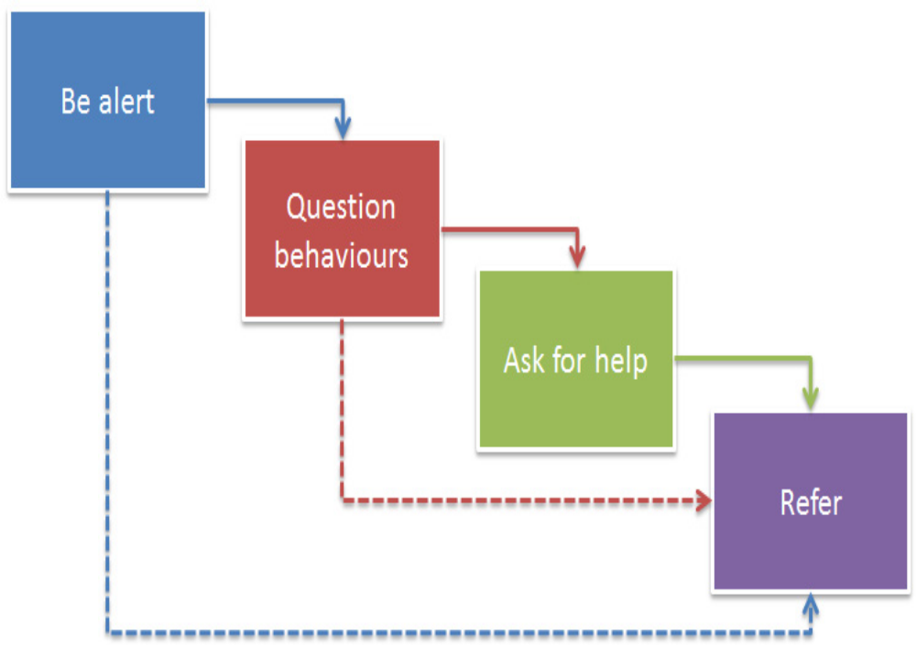

If a child is in immediate danger or is at risk of harm, you should refer to children’s social care and/or the police by ringing 999

Key contacts

Customer First – Children’s Social Care 0808 800 4005
Adults Social Care

Customer First - Professional Referral Line 03456 066 167

LADO Central ---Office line 0300 123 2044

Suffolk Constabulary 101

MASH Professional consultation line 0345 6061499

Local Safeguarding Board website www.suffolkscb.org

Suffolk Learning – www.suffolklearning.co.uk
(Safeguarding and Online safety)

