Tuesday 16th January 2017
Cursive Handwriting
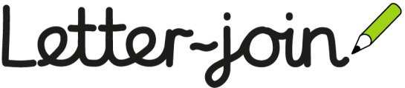
Dear Parents/ Carers,
We will be introducing ‘Letter join’ at Elveden Academy from today which is a new way of writing in a cursive style. The children are very excited about this as we have been modelling this in class since the beginning of term.
Cursive writing will start in reception, focusing on the formation of letters and how they start, moving onto joining in KS1 and KS2. Children in KS2 will initially use pencils to master the joins before moving onto pens, earning their pen licence in the new cursive style.
If you would like to have a look at this scheme for yourself, we have included instructions on how to access interactive lessons and resources on computers and tablets. The children should be able to show you all the interactive functions once we have used them more in school.
Miss Edmeades will also be holding a parent information session in school on Wednesday 31st January at 9am for anybody that would like further information.
Happy handwriting!
Mrs Rourke and Mrs Grimes

