R.E Spring 1 2018: Planned by ZM
Christianity: Symbols & Artefacts.
KQ: What are the best symbols of Jesus’ death and resurrection at Easter?
Day & Time | Subjects covered Session title | Key Objectives | Tasks & Differentiation including Key Questions |  |  | Assessment/  Plenary  Resources | Key Questions
1 | R.E | L.O: To engage with the idea of resurrection and part of the Easter Story. | (For this session you will need to prepare the Egg Hunt, by hiding the clues-when reflecting on the learning you may give them a small egg as a reward).  KQ: What are the best symbols of Jesus’ death and resurrection at Easter?  Chn will explore this question throughout the 5 weeks and revaluate it at the end. They must then show their understanding of what symbols they feel represents Jesus death at Easter time.  Start the session with all the chn on carpet and show them a Christmas souvenir or something that is special to you. Show them the object and tell them why it is special to you (it reminds you of family time, a personal event or someone special).  Introduce Tom &Tess (if you haven’t got the Christian dolls then just use 2 dolls, puppets or laminate the image) 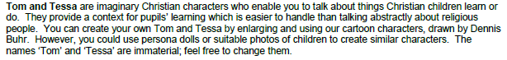  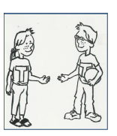  With Tom/Tess they have a bag (just use any drawstring type bag) inside the bag have a candle. It can be a trick one that never goes out or just pretend. Tom says is special because it reminds him of his party but it’s a trick candle,it never goes out. Tess has a flower in the bag, which her granny liked, she is dead and now her mum buys thes e flowers to remember her granny.  Then get a hot cross bun and chocolate egg out of the bag- Ask the chn what they are?. Explain that although people love these two things,they are two clues that are used to celebrate a christain festival. Ask the chn what the cross on the bun reprensts - can they identify the word Easter? Show them the egg next. Explain that although easter eggs are yum, Tom and Tess have actually brought them for us to have a easter egg hunt amd to learn christian stories..  Explain what the chn need to do: |  |  | Tom/Tess  Bag  1 hot cross bun  Candle  Flower  Chocolate eggs(if u want as a reward!)  Easter egg cards and story  Finish the session by lighting a candle and being still. Can they reflect on why Toms candle is a good symbol for Jesus (write down their reflections) | Who is Jesus?  Why is the candle a symbol for Jesus?  What do Christians believe Jesus is?  (he is the light of the world, even when he was killed his light was never distinguished)
1 | R.E |  | Group Task:  Get the chn into groups to do this actvity- they must try and find an egg outside or in the classroom- once each group has found an egg they wait till the others in their group join them and then share the story-  I would send a TA and you go with the BA groups and then mix up the others to include some good readers. Take photos of the chn finding an egg and sharing a story Once they have read a story ask them to look for the egg with the candle on. When the first group has found this, the game has finished as they all come back to class- ensure they have read one story as a group—when they come back discuss their stories briefly and ask them what the words on the candle egg could mean.  Explain that Jesus called himself the light of the world.When he was killed on the cross,everyone thought his light had gone out but it hadn’t! Just like a relighting candle.Tell the chn that for Christians, Easter time is about Ressurection-God bringing Jesus back to life again. It seems like a story with a sad end, but for Christains its not, as although he dies, he is resurrected; brought back to life.
1 | R.E |  | Extension:  Chn draw a picture and write about a souvenir that they have and why it is special to them. What does their symbol represent to them?
1 | R.E |  | Whose resurrection do we celebrate at Easter Time? | Why is the candle a symbol for Jesus? | Who do Christians believe Jesus is?

Day & Time | Subjects covered Session title | Key Objectives | Tasks & Differentiation including Key Questions |  |  | Assessment/  Plenary  Resources | Key Questions
2 | R.E | L.O: To enquire into the meaning of ‘souvenirs’ or symbols and start linking to Easter Stories. | (For this session you need an adult, teacher or TA, someone spare who can enter the classroom whilst you’re on the carpet and arrive in a fluster, explain they have travelled through time) See appendix 1: Time traveller script and here’s a list of their souvenirs- these will need to be collected before and placed in a bag).  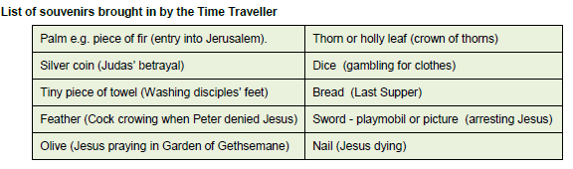  On the carpet as you wait for your visitor, ask the chn if they can remember the ‘symbols or souvenirs that Tom & Tess shared with us last week. Look at the hot cross bun, candle and Easter egg-how are they to do with Easter(write down the chn’s reflections on post its and add to their work later).Then show the chn the cross, why might this be important to Christians?> what does the cross represent?  The time traveller arrives and explain who she is and where she’s been (they have travelled back in time to Jerusalem 2000 BC and have souvenirs with them). |  |  | Hot cross bun, Candle, Egg  Cross  Appendix 1: Time traveller Script  Objects from List of Souvenirs  Revisit the key question after the story-are any of these objects the best symbols/reminders of Easter? Post it children’s reflections. | What does the cross represent to Christian’s?  What were the people told about Jesus when he was put on the cross?  How did God show his Son was still alive?
2 | R.E |  | Group Task:  In small groups, the chn look at the time traveller’s souvenir’s and try to work out how they are linked to the Easter Story. Bring chn to the carpet and discuss their ideas about each object. After that show them the Easter story- this explains all the objects that our visitor brought with them. https://www.topmarks.co.uk/Easter/EasterStory.aspx  Revisit the key question after the story-are any of these objects the best symbols/reminders of Easter? Share ideas and chn write their ideas on post its ready to put into the RE folder with the photo of lesson. Teacher to also add any reflections from the chn.
2 | R.E |  | Extension: Chn to draw an object that they would have brought back from Jerusalem to represent Jesus resurrection.
2 | R.E |  | What does the cross represent to Christian’s? | What were the people told about Jesus when he was put on the cross? | How did God show his Son was still alive?

Day & Time | Subjects covered Session title | Key Objectives | Tasks & Differentiation including Key Questions |  |  | Assessment/  Plenary  Resources | Key Questions
3 | R.E | L.O: To explore more of the stories of Easter and the feelings associated with this time. | (The classroom must be set up with two separate areas- one for the ‘remembering activities’ and the other for the ‘rejoicing activities’- you will need: playdoh, flowers in a vase, wax crayons, card, paints, rainbow & candle template, black card, glue, black card, glitter)  Recap the Easter Story- can the chn remember and name the objects/souvenir’s that the time travelling visitor brought back from Jerusalem?  Then ask the chn if symbols always have to be objects like the souvenirs? Draw a smiley face and a not so smiley face on w/b. Ask the chn if these could be symbols of Easter? How? What parts of the story could they remind us of? Discuss when Christian’s were happy and sad in the Easter story.  Explain that today we are going to think about the feelings/ emotions that Christians have at Easter time and see if these can help us choose other symbols for Easter.  Set up two separate learning areas in the classroom:  On one side have the tables laid out with ‘Remembering’ activities:  As you show the chn these activities read them the prompt-Explain that here they can explore the activities thoughtfully and quietly. Tell them that their memories are important-sad ones and good ones and as you go around assess what the chn’s art work means to them-write on post its.  Activity 1:  Play dough with the card ‘Who do you love and remember who had gone?’ Chn make a model of their loved ones out of play doh  Activity 2: ‘Cheer someone up’ Flowers cheer up people-Chn use wax crayons to create paint a vase of flowers-have some vase of flowers or images of flowers on table/if u feel brave let them make flowers with tissue paper/pipe cleaners. Model this.  On the other tables have the ‘Rejoicing activities. Read the prompt before explaining the activities:  Activity 3: ‘What makes you happy? ‘Chn create rainbows and draw what makes them happy at one end of the rainbow-explain that like the pot of gold, it could be something they love to do or someone they love.  Activity 4: ‘A light that doesn’t go out’- Christians say that Jesus is the light of the world- Chn to draw a candle in the glue on a small black card and dip it in shiny glitter.  This is a free flow activity and chn can go and complete what that want-ensure you listen to their reflections and record what the symbols they make, mean to them. Take photos of the chn’s final art work. |  |  | Play doh  Paints  Glue  Glitter  Black card 5x5cm  Chn write on post it what their crafts represent | Who was crucified at Easter?  How do you think God felt about giving up his son?  What feelings do you think Christians have at Easter time and why?
3 | R.E |  | Extension:  Chn write about their art work that they have created. Why did you choose it to portray your feelings?
3 | R.E |  | What emotions did the Christian feel at Easter? | Who do Christians believe is with them when they are full of sorrow? | What does Jesus mean to Christians?

Day & Time | Subjects covered Session title | Key Objectives | Tasks & Differentiation including Key Questions |  |  | Assessment/  Plenary  Resources | Key Questions
4 | R.E | L.O: To evaluate our learning about symbols of Jesus death and resurrection and decide which is the best symbol | Ask the chn to recall the symbols that we have looked at that can represent Jesus Resurrection- the cross, has to be the one that most Christians view as being a symbol of Easter. Show a cross to the chn and explain that the cross is a reminder that Jesus died but it can also show much more. Resurrection, Forgiveness and love-discuss this with the chn and model on the board a large cross and write these key words around it-can chn think of any more words that the cross could signify? Then show them a Easter egg (a small plastic egg will do) Tell the chn that an egg looks very ordinary, even dead, but most incredibly, a chick can hatch out of an egg, making new life- Explain that this also could be a symbol of Jesus’s resurrection as Jesus went from being dead to being alive again. And an egg is a brilliant symbol for this.  Tell the chn that how they are going to evaluate what they learnt about Jesus Resurrection by creating either a cross or an egg-they must also reflect on what it signifies to Christains. |  |  | Paper march or mod roc  Croos template on card  Paper to scrunch up for egg shape  Paints  Tissue paper pieces  Bring chn’s creations to carpet and let them share their thoughts about their creations. How does it show Jesus? | How did Jesus die?  What does the symbol of an egg represent?  Why is the cross a vital symbol to the Christian faith?
4 | R.E |  | Chn create their own crosses or eggs to depict their symbol of Resurrection- They can use paper marche or mod roc to make the eggs and then paint them or cover the cross template with pieces of tissue paper cut up to make a collage pattern. On their post it they must say what their symbol represents- if they use red tissue or paint could that be Jesus’ blood?  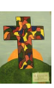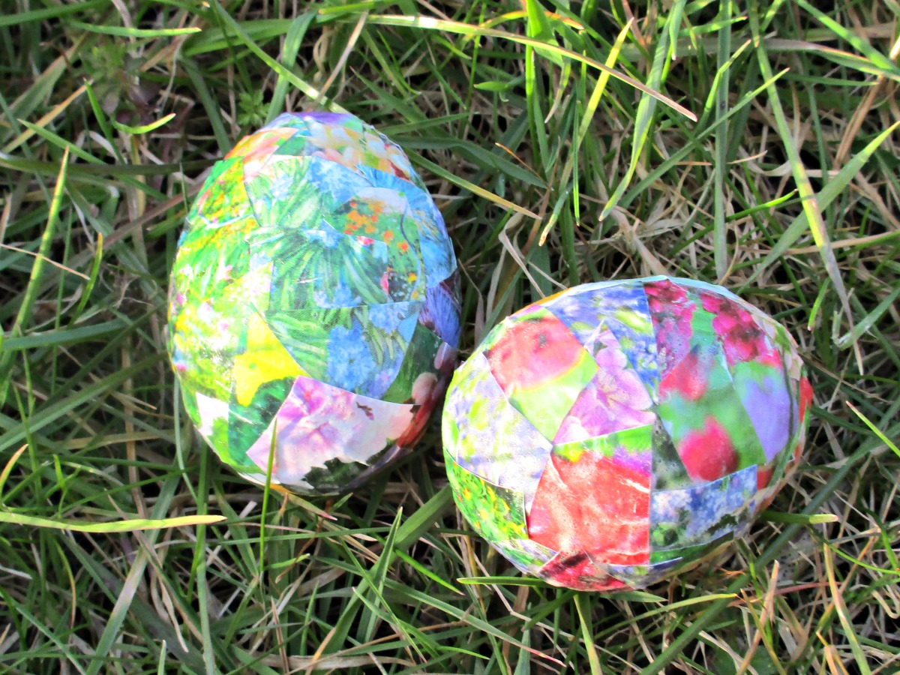
4 | R.E |  | Extension: Chn use ipads to research the Palm Cross and the Empty cross- can they explain what they represent?
4 | R.E |  | How did Jesus die? | What does the symbol of an egg represent? | Why is the cross a vital symbol to the Christian faith?

Day & Time | Subjects covered Session title | Key Objectives | Tasks & Differentiation including Key Questions |  |  | Assessment/  Plenary | Resources
5 and 6 | R.E  Week 5 and 6 | L.O: To express our RE learning so that it can be shared with others. | The last two lessons will be to express the chn’s thoughts of the Resurrection- In this expressive session chn show what they have learnt about Christian belief in Jesus Resurrection at Easter.  Recap and review our half-term’s learning. Chn will answer the following question: What are the best symbols of Jesus’ death and resurrection at Easter? Discuss this question with them.  Over the next two weeks chn get the chance to create art work that you could use for a Resurrection display.  At Elveden, the artwork will be on a larger piece of paper or white sheet, chn will create their own artworks and add it to the whole class piece of reflective artwork. I was thinking of a hillside with their crosses, flowers, etc placed on it –or I may even get them to paint them on it as a class.  If you have a TA you could set up 2 different activities but if on your own do one this week and another the following week.  Chose one of the following:  Have a large cross template ready for the children to sketch patterns and designs of what they think represent Resurrection. Chn can paint them or colour ready to add them to the class artwork.  Next lesson, using the big paper or a white sheet- sketch up the background scene –discuss with the chn what they would like to add to it-either you or TA sketch these images on , such as hills, sunset, flowers, etc. Together or in small group chn all have a turn at painting a piece on the artwork-you can then get them to place their finished crosses in the field-if any chn want to make flowers from tissue paper/pipe cleaners u can do this at same time.  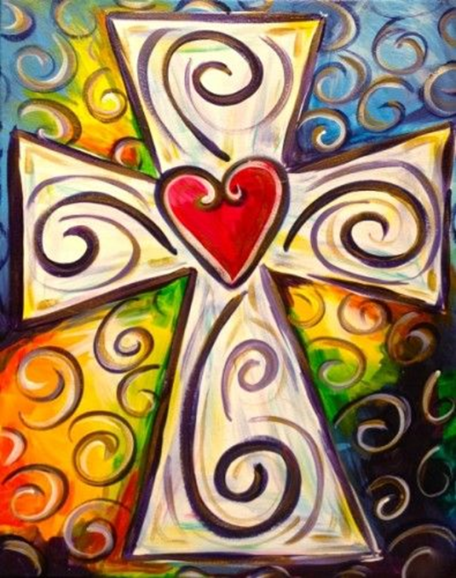  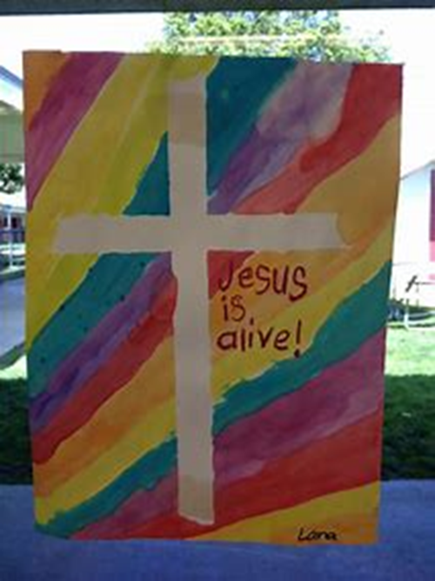  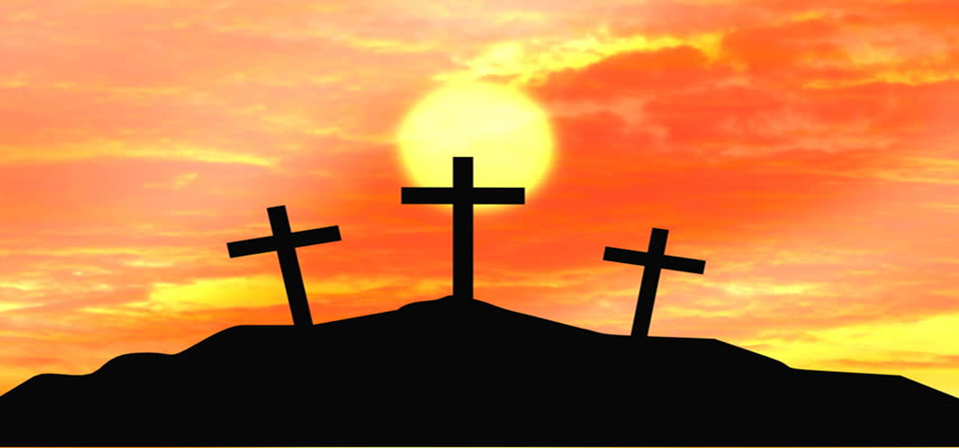 |  |  | What happened when Jesus was put on the cross?  How do you think Christians feel every Easter?  What other symbols could be used to represent Jesus’ Resurrection? | A big sheet or wallpaper  Paints  Big cross templates  Acrylic paint if using a sheet.
5 and 6 | R.E  Week 5 and 6 |  | What happened when Jesus was put on the cross? | How do you think Christians feel every Easter? | What other symbols could be used to represent Jesus’ Resurrection?

