Fun with Liz Million
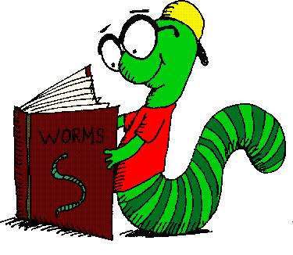

On Monday 26th February Squirrel and Fox class went over to Forest Academy to meet children’s author and illustrator Liz Million. They had so much fun learning how to draw different characters and even had a go at drawing their own dragon.


